Lesson 4: Functions
Math 2412 Precalculus · Unit 1: Algebra Foundations & Functions · Student Guided Notes
Name: ______________________________ Date: ______________

Lesson objective
Students will evaluate functions and difference quotients, find domains, evaluate and graph piecewise functions, and read key features from a graph.

Before class
Complete these short tasks before the lesson. They review skills this lesson builds on.
- Write four number-line graphs in interval notation (Lesson 3, Skill 3.1).
- Solve $x^{2}−4≥0$ with a sign chart (Lesson 3, Skill 3.3).
- Expand ${(x+h)}^{2}$ and ${(x+h)}^{3}$ (Lesson 1).
- Graph $y=2x−1$ by making a table of values.

Skill 4.1: Function Notation & the Difference Quotient

Key ideas
- A ______________ (1) is a correspondence between two sets.
- A ______________ (2) from X to Y is a relation that assigns each element of X exactly one element of Y.
- On a graph: if every vertical line crosses the graph at most once, the graph is a function (the ______________ (3)).
- To evaluate $f(a)$, replace every x in the formula with a, using parentheses.
- The difference quotient of f is $\frac{f(x+h)−f(x)}{h}$, with $h≠0$. It measures the average rate of change; you will see it again in calculus.

Steps: find a difference quotient
- Find $f(x+h)$ by replacing every x with $(x+h)$. Expand.
- Subtract $f(x)$. Every term without h should cancel.
- Every remaining term has a factor of h. Factor it out.
- Cancel h with the denominator and simplify.

Example: $f(x)=x^{2}−x+2$
Evaluate. $f(−1)={(−1)}^{2}−(−1)+2=4$ and $f(3)=9−3+2=8$.
Step 1. $f(x+h)={(x+h)}^{2}−(x+h)+2=x^{2}+2xh+h^{2}−x−h+2$.
Step 2. $f(x+h)−f(x)=2xh+h^{2}−h$.
Steps 3–4. $\frac{h(2x+h−1)}{h}=2x+h−1$.

Practice
a. For $f(x)=3x^{2}−2x$, find $f(−2)$. | b. For $f(x)=x^{2}−3$, find $f(a+1)$.
c. Find the difference quotient for $f(x)=4x−5$. | d. Find the difference quotient for $f(x)=\frac{1}{x}$.

Skill 4.2: Domains of Functions

Key ideas
The domain is the set of all x-values that can be used. It is found by looking for x-values that break a math rule.
Type | Rule | Sample domain | What to do
Polynomial | no restrictions | (−∞, ∞) | nothing: all real numbers
Square root | the inside must be ________ (4) | [a, ∞) or (−∞, a] | set the inside ≥ 0 and solve (sign chart if needed)
Fraction | the denominator cannot be ________ (5) | (−∞, a) ∪ (a, ∞) | set the denominator = 0, solve, and exclude those values
Logarithm | the inside must be ________ (6) | (a, ∞) | set the inside > 0 and solve

Square root in a denominator, such as $1/\sqrt{x−1}$: the inside must be strictly greater than 0.

Steps: find a domain
- Identify every square root, denominator, and logarithm in the formula.
- Write the restriction each one creates as an inequality or "≠" statement.
- Solve each restriction. Use a sign chart for nonlinear inequalities.
- Combine the restrictions and write the domain in interval notation.

Examples
- $f(x)=log(x+2)$: $x+2>0$, so $x>−2$. Domain (−2, ∞).
- $g(x)=\sqrt{3−x}$: $3−x≥0$, so $x≤3$. Domain (−∞, 3].
- $h(x)=\frac{1}{x^{2}−4}$: $x^{2}−4≠0$, so $x≠±2$. Domain (−∞, −2) ∪ (−2, 2) ∪ (2, ∞).
- $k(x)=\sqrt{x^{2}−4}$: $x^{2}−4≥0$. A sign chart gives (−∞, −2] ∪ [2, ∞).

Practice
Find the domain. Write it in interval notation.
a. $f(x)=x^{3}−5x$ | b. $f(x)=\frac{x+1}{x^{2}−9}$
c. $f(x)=\sqrt{2x+8}$ | d. $f(x)=1/\sqrt{x−1}$
e. $f(x)=log(5−x)$

Skill 4.3: Piecewise-Defined Functions

Key ideas
- A ______________ (7) function uses different formulas on different parts of its domain.
- To evaluate, first find which ______________ (8) the input satisfies, then use only that formula.
- When graphing, mark each endpoint closed (included) or open (not included).

Example 1: a cell phone plan
A plan costs $20 for the first 60 minutes and $0.40 for each additional minute.
C(t) = | when
$20$ | $0≤t≤60$
$20+0.40(t−60)$ | $t>60$

$C(30)=20$, using the first piece. $C(120)=20+0.40(60)=44$, using the second piece.
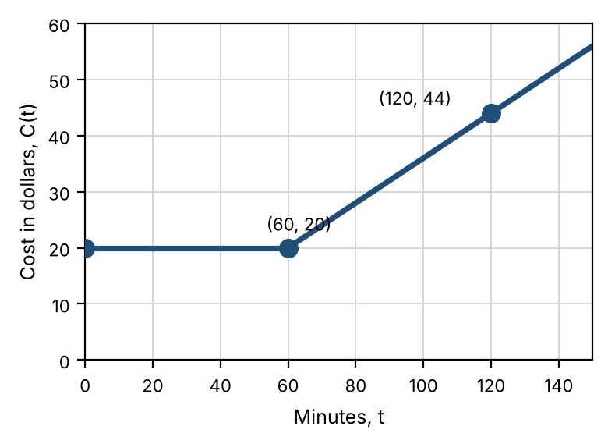

Steps: evaluate and graph a piecewise function
- To evaluate: decide which condition the input satisfies, then substitute into that piece only.
- To graph: make a small table for each piece, including its boundary x-value even if the boundary is not included.
- Mark each boundary point closed (≤ or ≥) or open (< or >).
- Draw each piece only over its own interval.

Example 2: evaluate
f(x) = | when
$6x−1$ | $x<0$
$7x+3$ | $x≥0$

$f(−3)=6(−3)−1=−19$, $f(0)=7(0)+3=3$, and $f(4)=7(4)+3=31$.

Practice
a. For $f(x)=x^{2}−1$ when $x<2$ and $f(x)=5−x$ when $x≥2$, find $f(−3)$, $f(2)$, and $f(5)$. | b. Graph $g(x)=x+2$ when $x<1$ and $g(x)=−x+5$ when $x≥1$.  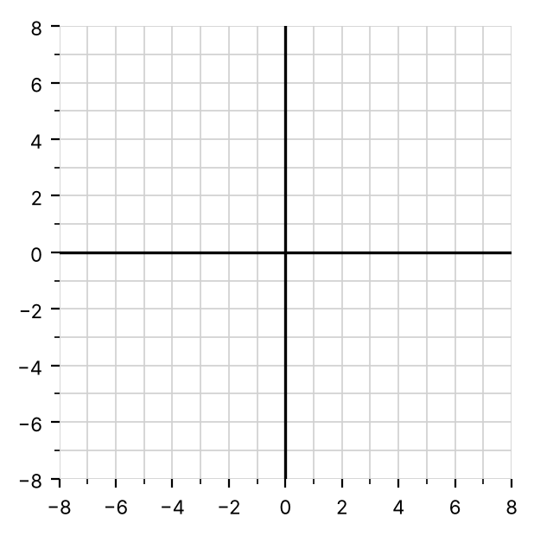
c. A data plan costs $15 for up to 2 GB and $10 for each GB over 2. Write a piecewise function D(g) and find $D(3.5)$.

Skill 4.4: Reading Features from a Graph

Key ideas
- Domain: read the graph from ______________ (9). Range: read it from ______________ (10).
- An open circle means that point is not on the graph. A closed circle means it is.
- Zeros: the values of x where $f(x)=\{\{0\}\}$. They are the x-coordinates of the ______________ (11).
- The y-intercept is the point where $x=0$, or $(0,f(0))$.
- To find $f(a)$ from a graph, go to $x=a$ and read the y-value of the graph there.

Example: Graph A
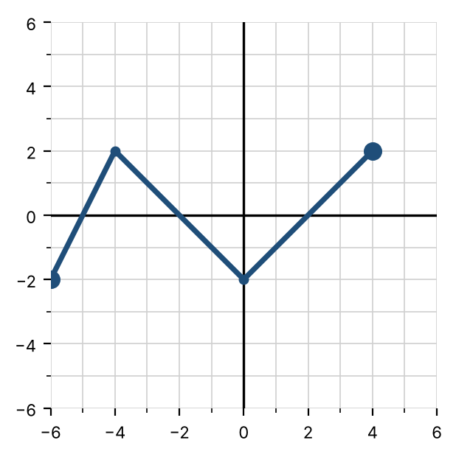
Feature | Graph A
Domain | [−6, 4]
Range | [−2, 2]
x-intercepts | (−5, 0), (−2, 0), (2, 0)
y-intercept | (0, −2)
Zeros | $x=−5$, $x=−2$, $x=2$
$f(−4)$ and $f(2)$ | $f(−4)=2$, $f(2)=0$
Solve $f(x)=2$ | $x=−4$ or $x=4$

Practice: Graph B
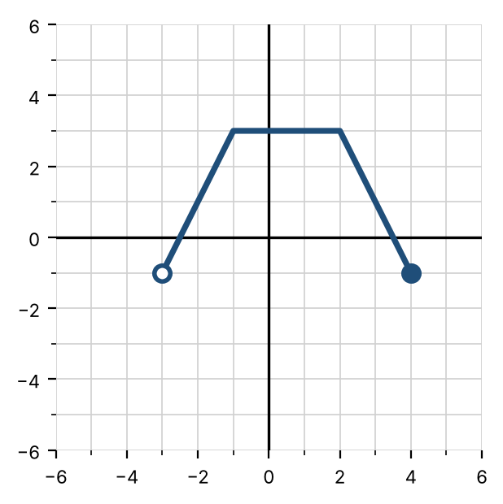
Feature | Graph B
Domain | ________ (12)
Range | ________ (13)
x-intercepts | ________ (14)
y-intercept | ________ (15)
Find $f(−1)$ | ________ (16)
Find $f(4)$ | ________ (17)
Solve $f(x)=3$ | ________ (18)

Exit check
1. For $f(x)=2x^{2}−3$, find $f(−2)$.

2. Find the domain of $f(x)=\sqrt{x−5}/(x−7)$.

3. For $g(x)=3x$ when $x<1$ and $g(x)=x^{2}$ when $x≥1$, find $g(1)$.

